Celsius scale thermometer at temperature T at which the liquid is extended to a distance & beyond the zero position. Thus here temperature can be calculated by

L₀

 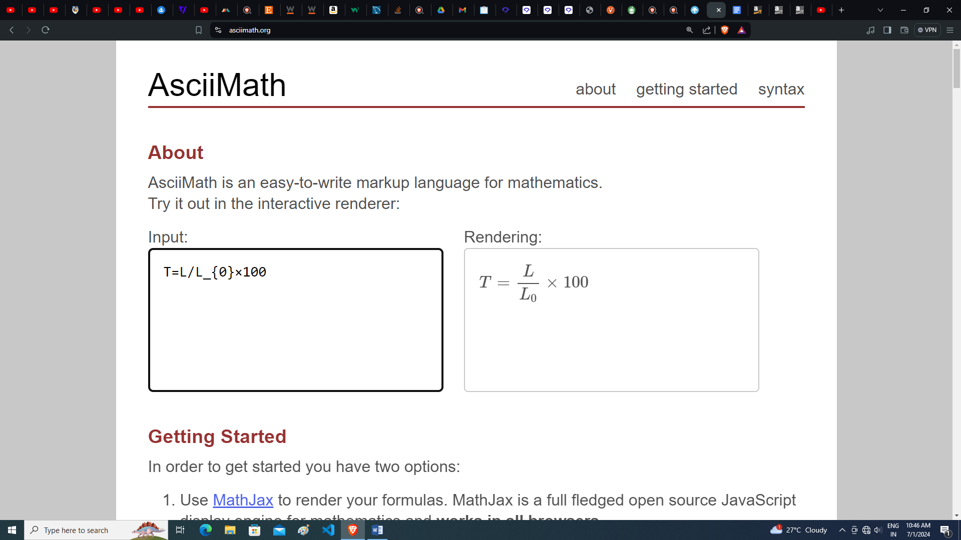

L

100⁰C

0⁰C

Although the Celsius temperature scale is widely used, there is nothing fundamental about choosing the ice point to be 0° and the steam point as 100". The Fahrenheit temperature scale assigns a value of 32" to the ice point and 212" to the steam point, a difference of exact 180°. Similarly there can be so many temperature scales having different numerical values assigned for ice point and steam point respectively. It is easy to transform temperature in one system into temperatures in the other system. The general transformation formula used for this is

$$\frac{temperature in X scale-ice point in X scale}{Steam point in X scale -ice point in X scale}$$

$= constant for alll temperatures$

Eg:

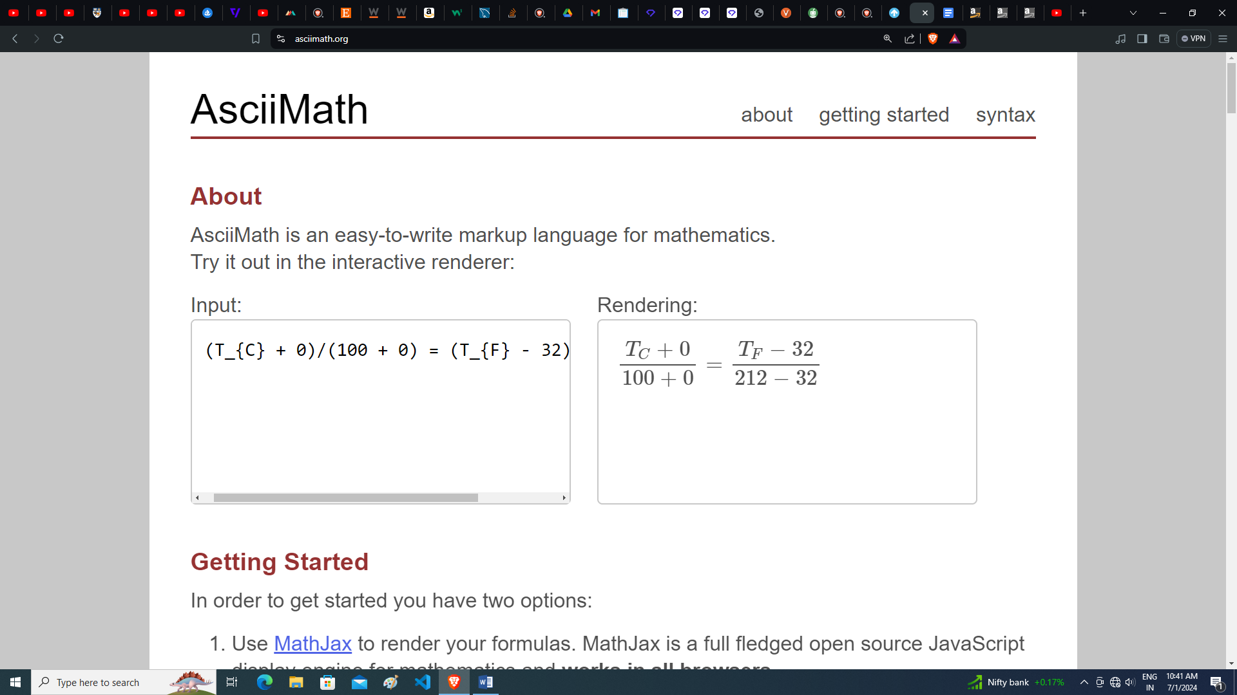



The Kelvin scale is based on the fact that a gas at 0°C will

lose 1/273.15 of its volume for a 1°C drop in temperature. If this reduction in volume were to continue with decreasing temperature and if the gas did not liquefy, the volume would become zero at-273.15°C. This is a temperature called absolute zero. The temperature scale based on this zero is the Kelvin temperature scale. If we use equation to establish the relationship between Celsius and Kelvin

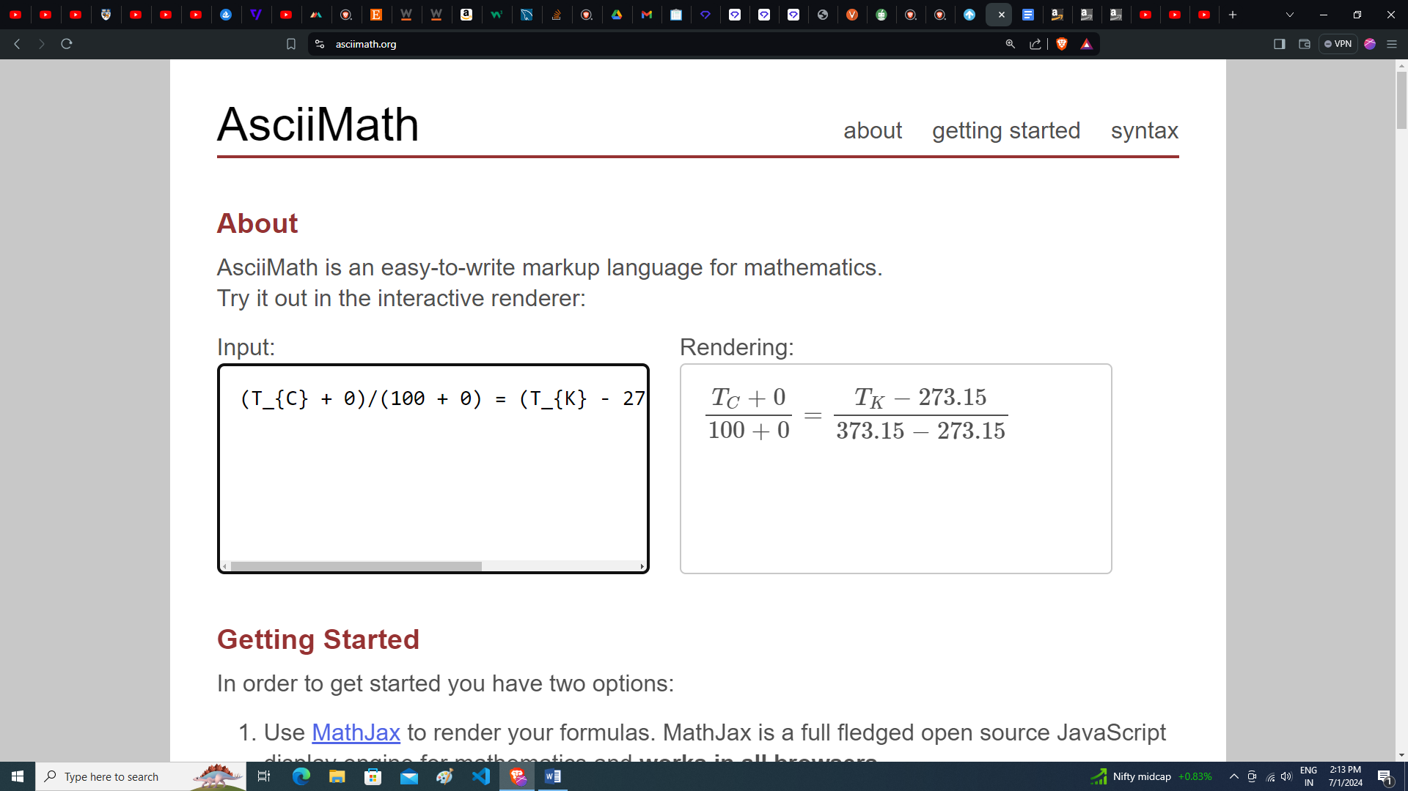

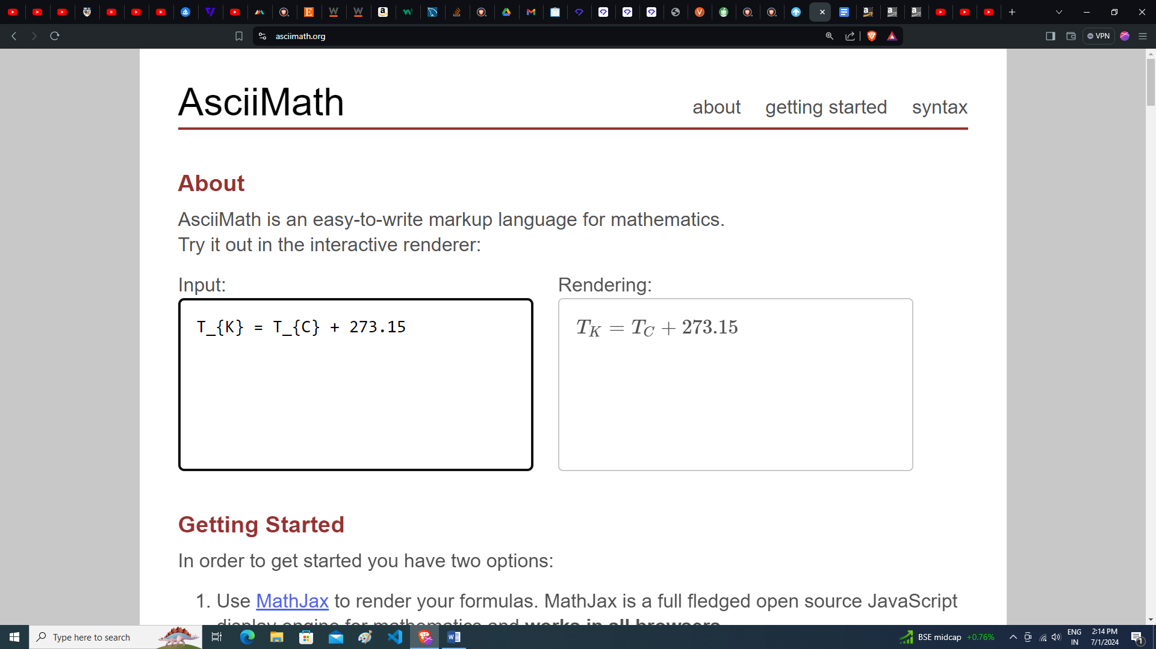

The temperature in Kelvin is called absolute temperature.

Linear Expansion

This is expansion in dimension of length of a solid body. It takes place only in solids. To explain linear expansion we take a simple example of a ruler scale. A ruler scale of length L at temperature T. If the temperature of scale increases, due to thermal expansion, its length also increase. It is observed that on increasing temperature by ∆T, the expansion in its length ∆L is directly proportional to the rise in temperature ∆T as



It is also observed that expansion of large object is more due to more number of molecule and equal increase in all intermolecular spacing increases the dimensions proportionally, thus we can say that the expansion in its length AL is also proportional to the initial length of the scale as







Thus the final length at higher temperature can be given as





Here α is the proportionality constant which depends on the material of the body in simple cases, and is called coefficient of linear expansion. Theoretically α is supposed to be a constant but practically it is seen that the value of α varies with temperature and its relation also changes with temperature depending on the range of temperatures. But for a short range of temperature α can be taken as a constant.

can use the same result to find the final radius of the disc a

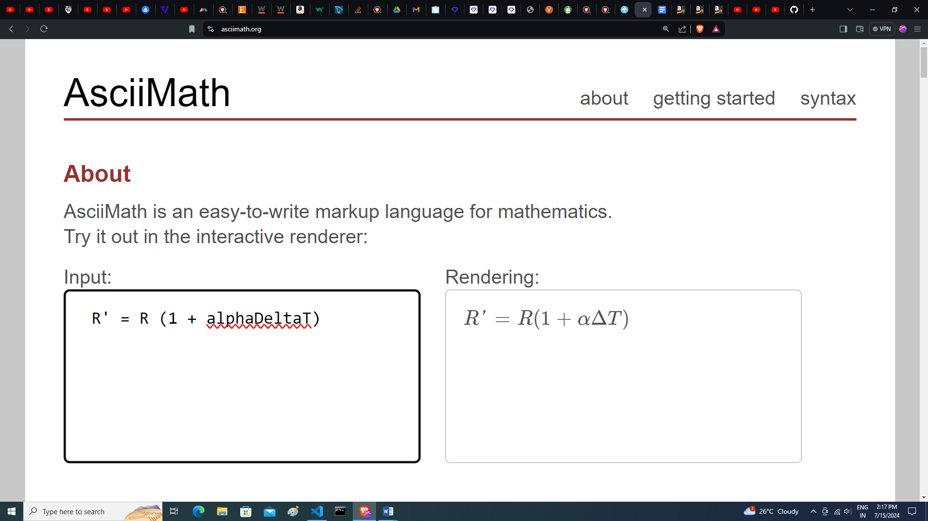

Similarly this expression can also be used to find the distance between any two points on a body



Where α is the coefficient of linear expansion of material of rod.

l

A

B

l`

B

A

Stress in Objects Due to Thermal Expansion

ln thermal expansion the inter molecular separation between molecules of an object increases

.

l

A

B

Clamp

Temperature=T

B

A

Temperature = T + ∆T

L

∆L

A

B

F

F

B

A

Temperature = T - ∆T

if wire is not clamped at end B, its new length should become AC which is L - ∆L If it is externally stretched and the end C is tied to clamp B, this ∆L will be the extension in string length due to its elasticity. If cross-sectional area of wire is S and F be the tension developed in wire due to stretching. Thus the stress developed in the wire due to this tension F is given as

stress = $\frac{\text{F}}{\text{S}}$

Strain produced in wire due to its elastic properties is

strain = $\frac{∆L}{L}$ = α∆T

 If Young's modulus of the material of wire is Y, we have

Y= $\frac{stress}{strain}$

Y= $\frac{F/S}{α∆T}$

F = YSα∆T

If it already has some tension in it then this expression will give the increment in tension in the wire.

Variation in Time Period of Pendulum Clocks by Thermal Expansion

In pendulum clocks, their oscillation period depends on length of pendulum and the acceleration due to gravity and is given

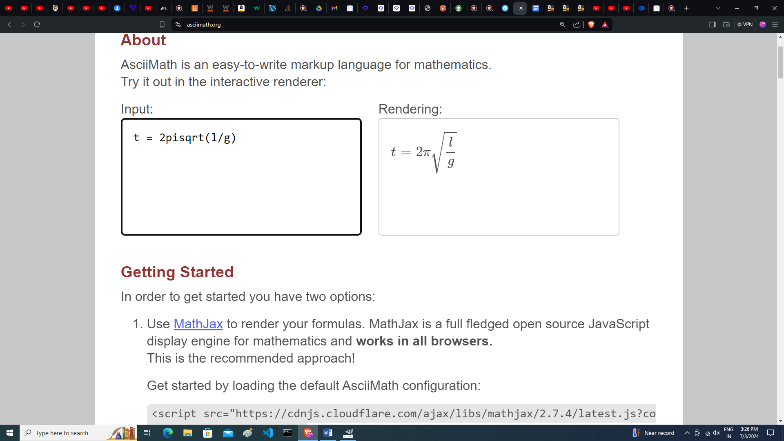





[If ao is the coefficient of linear expansion of material of pendulum rod]

 (binomial approximation)





It gives the increase in period of oscillation of the pendulum and we can see that the increase in time period depends on the rise in temperature as well as the initial time period of oscillations.

Here if we find the change in time per second, we get



It gives the time lost per second by the pendulum clock. If ∆T is the fall in temperature, same equation will give the time gained by the clock per second as its oscillation will become faster due to reduction in its length

Areal expansion

If a be the coefficient of linear expansion for the material of plate, its final length and width at higher temperature can be given as

(b’ is the change in breadth and l’ in length of the rectangle sheet)





 

 [initial area A = lb]



 [As α∆T <<1 using binomial expansion]



Here β = 2α is called coefficient of superficial expansion for the material of object. In some objects if linear expansion coefficient α is not very small (which is very rare), we can not use β = 2α for that material as binomial expansion can not be used and value of ẞ can only be experimentally evaluated.

it can be seen that temperature of a body if decreases, its final area at lower temperature can be given as



For small beta we can write this expression as



Cubical or Volume Expansion

As we know when temperature of a body increases, thermal expansion takes place uniformly in all directions. Due to this Volume of body also increases. Consider a box of length, width and height lbh If its temperature increases by ∆T and the coefficient of linear expansion for the material of box is a, the final volume of box will be given as





[Where Vi = lbh and for α∆T<< 1 ]



Here γ= 3α is called coefficient of volume or cubical expansion of the material of body. In case of expansion of liquids, length and area do not have any significance and so for a liquid we can only define coefficient of volume expansion. In liquids molecules are more mobile as compared to solid thus expansion of liquids is always more than that of solids, thus the value of y is also higher for liquids than solids.

Variation in Density of a Substance

We know volume of a substance increases with rise in temperature. Thus we can obviously state that the density of object decreases with rise in temperature as its mass is a constant. For example if a body of mass m has

ρ1 and volume V1 at temperature T, then at some higher temperature T + ∆T the volume of body V2 can be given as



If the density of body now becomes ρ2 then it can be given as







[As for γ∆T << 1 ]

We have discussed that with temperature expansion rate of liquids is faster than solids thus some times in case of liquids when coefficient of expansion y is not a very small value, above equation-(1.42) will not be valid, as we can not use binomial approximation as γ∆T is not very less than 1. Then variation of density of such liquids is given by

Weight liquid overflow

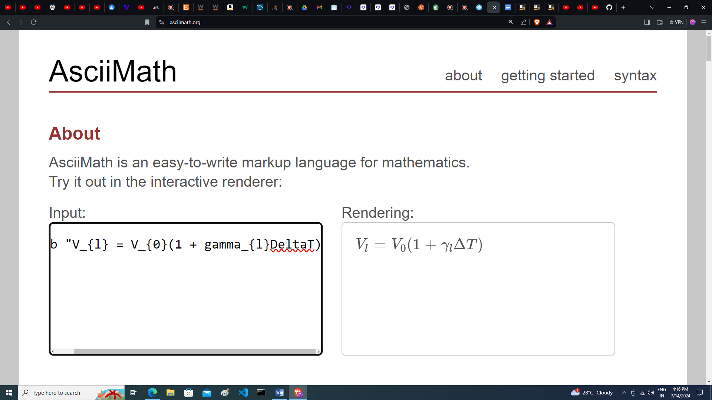

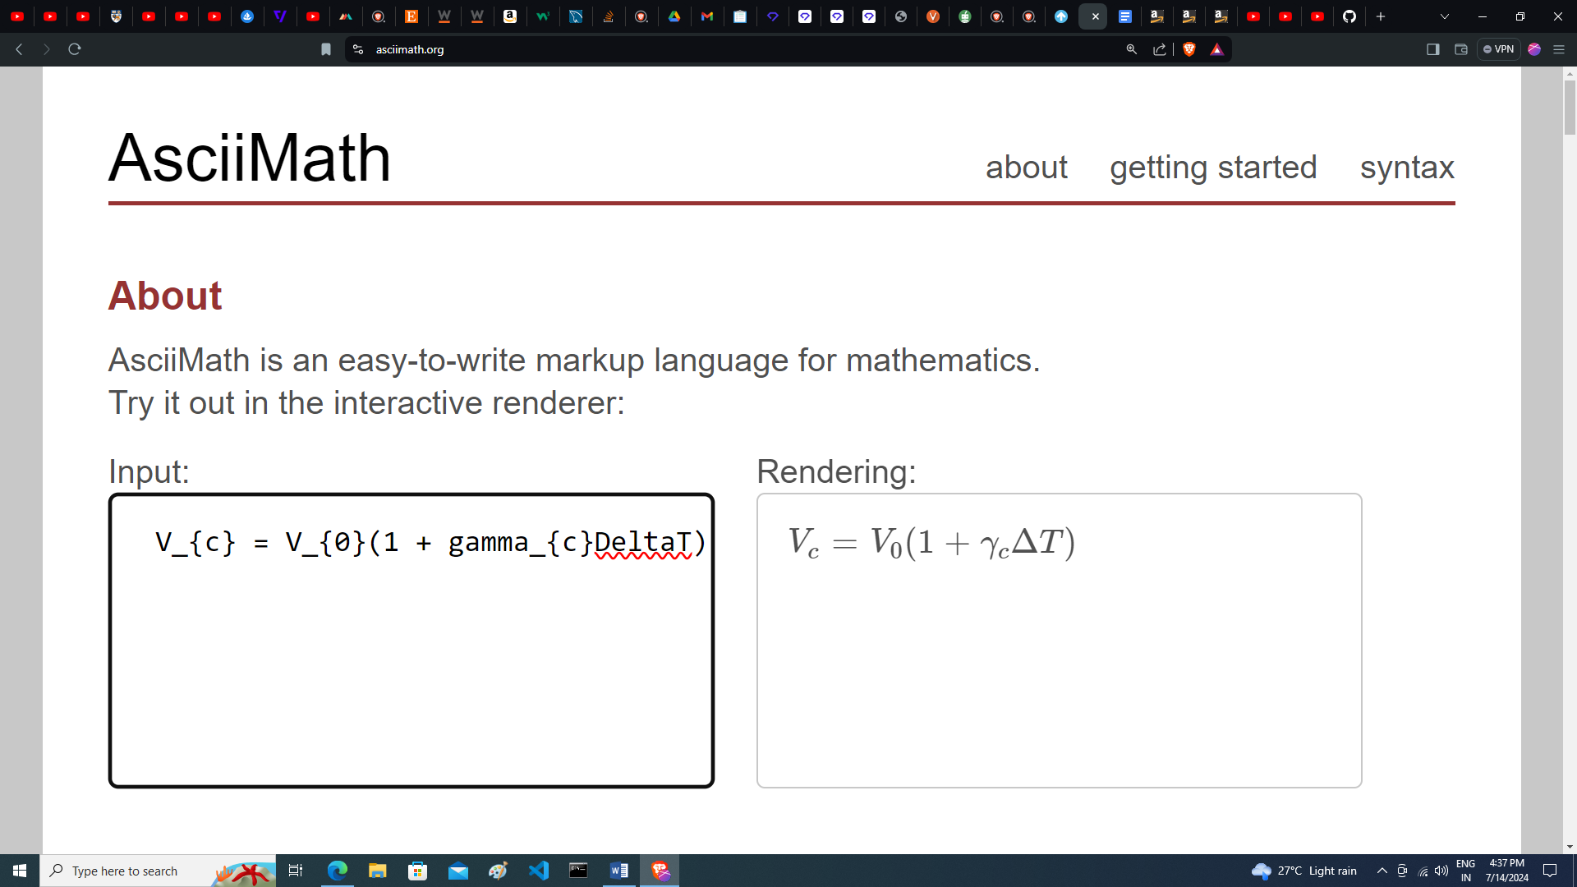

As γl > γc liquid will expand more than container and some liquid expel from the container. The volume of overflow liquid can be given as

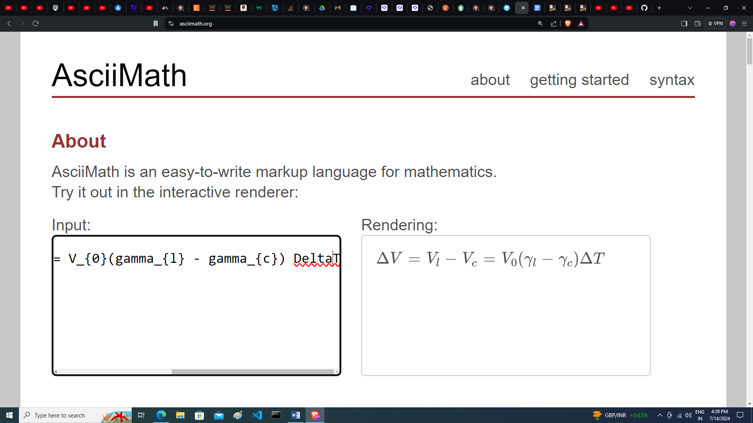

Here this volume ∆V can be taken as apparent expansion of liquid relative to container and the term

(γl – γc)is called as coefficient of apparent expansion of liquid respect to glass and can also be denoted by γlc thus we can write the volume of liquid overflow is

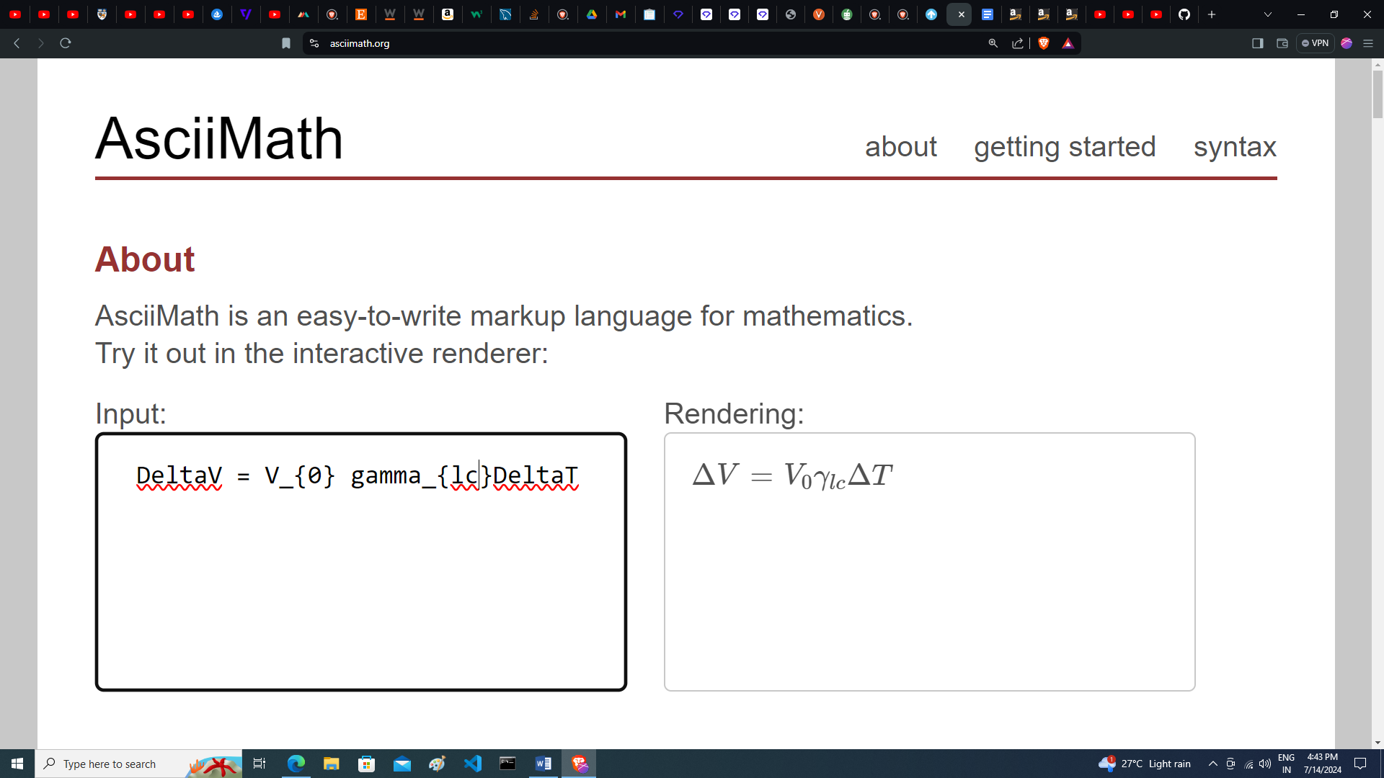

The density of liquid at this higher temperature is given as

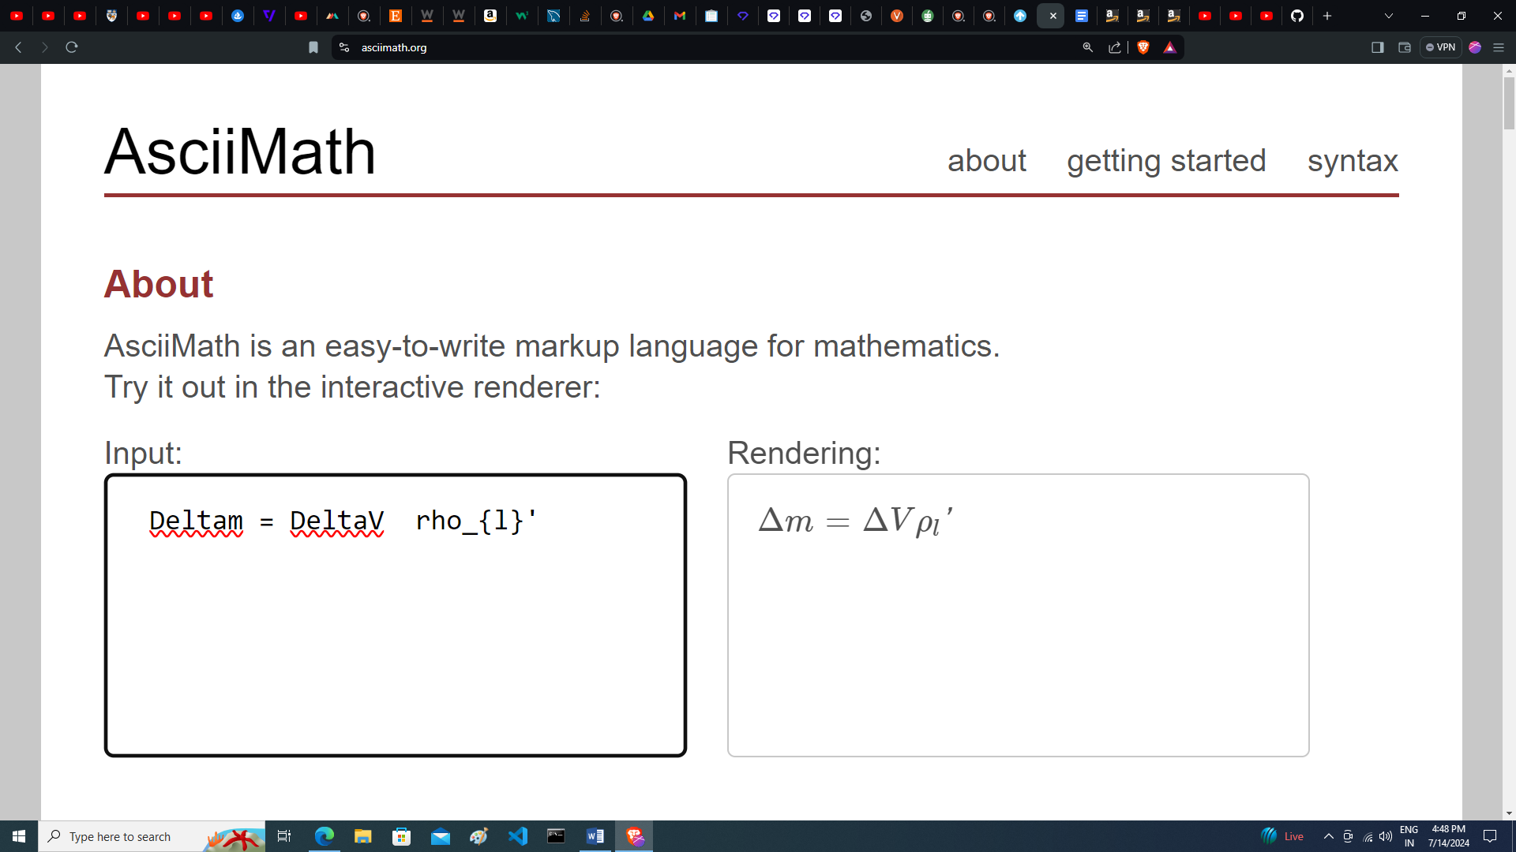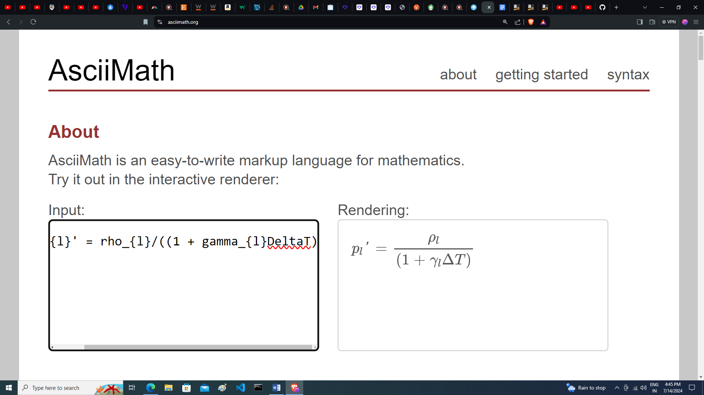

 Mass of liquid overflow is

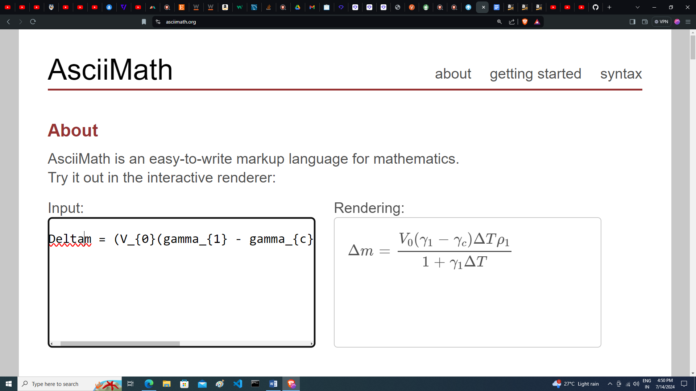

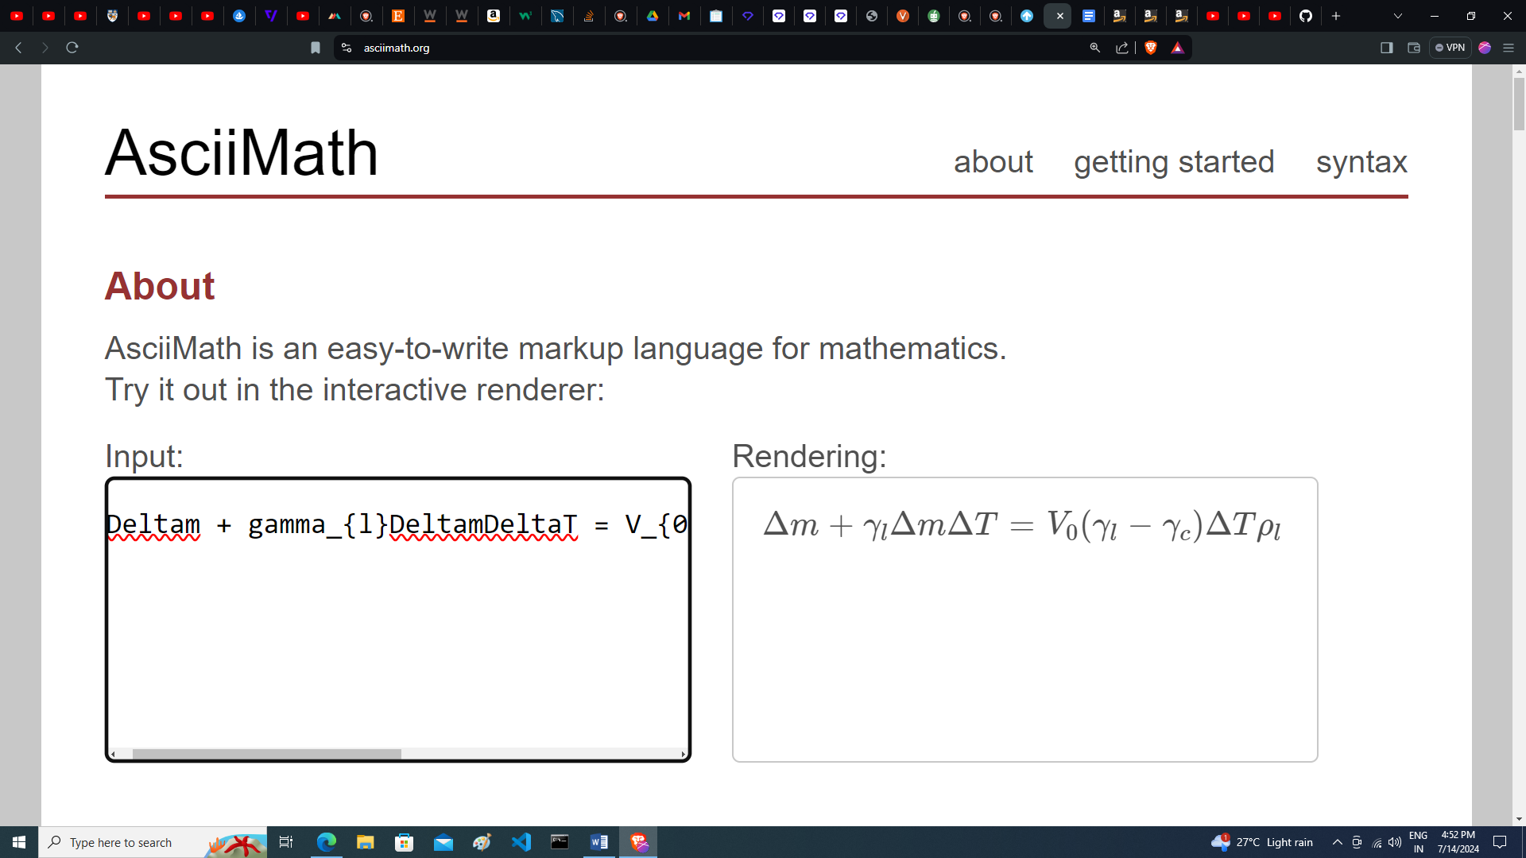

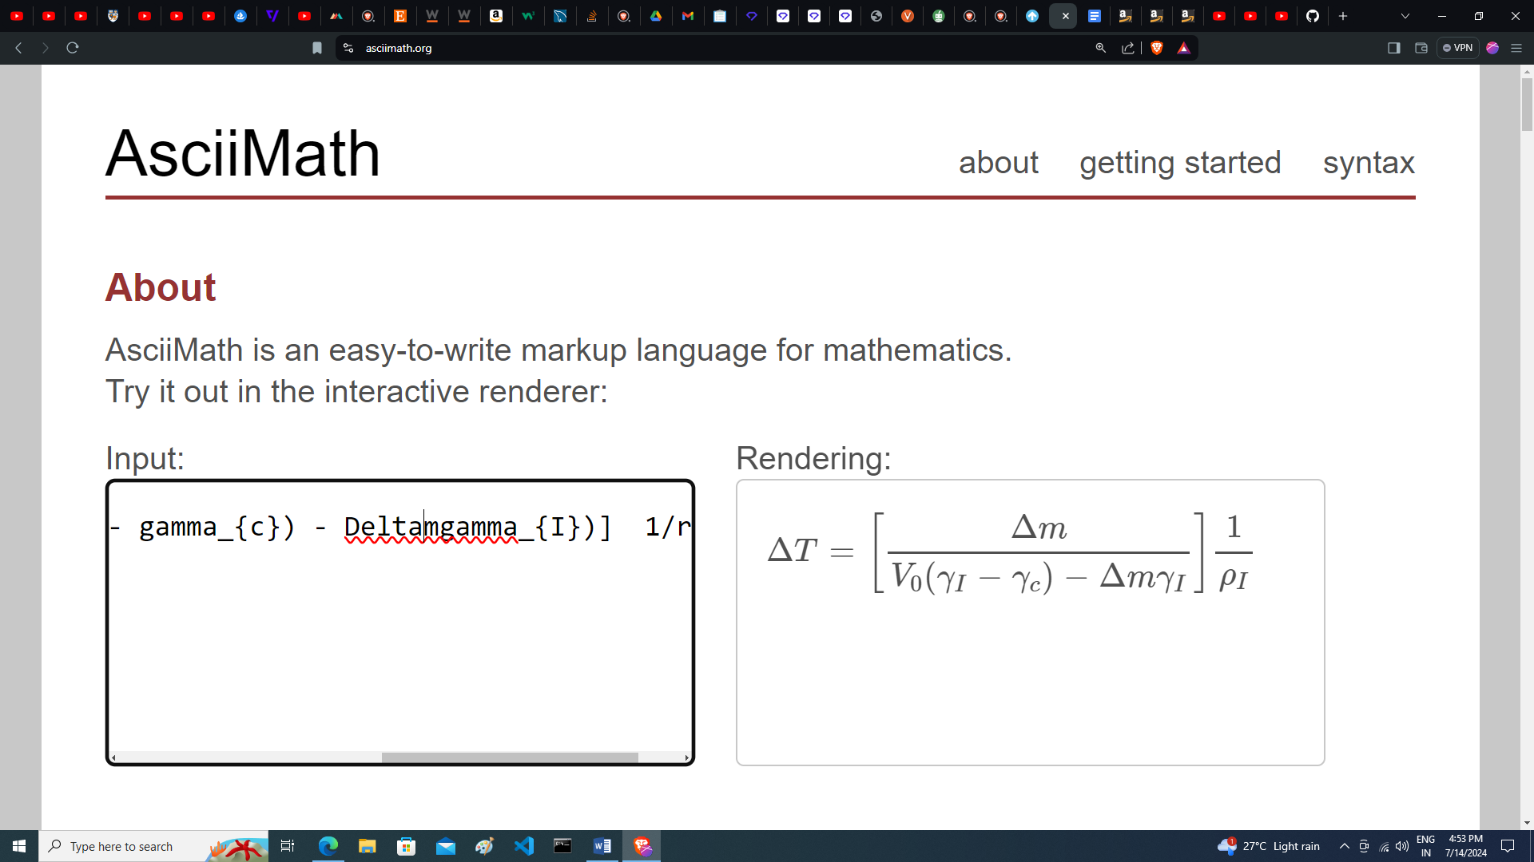

If we weight the mass of liquid overflown, then using the above expression we can find the rise in temperature.

Thus when a solid expands uniformly in all three dimensions, this is called isotropic expansion of solid. In isotropic expansion this is coefficient of linear expansion a remains, same in all three dimension and thus the volume coefficient of thermal expansion can be written as

γ = 3α

When expansion of solid is different in the three dimensions due to atomic arrangement in solid lattice structure, this is termed as anisotropic expansion of solids. In anisotropic expansion the coefficient of linear expansion of solid is different in different dimensions of solid. For example in a piece of graphite if α1 is the linear expansion coefficient in x and y direction (along the plane of carbon layers) and α2 is the linear expansion coefficient in z direction (normal to graphite layers) then the coefficient of cubical expansion of solid is given as

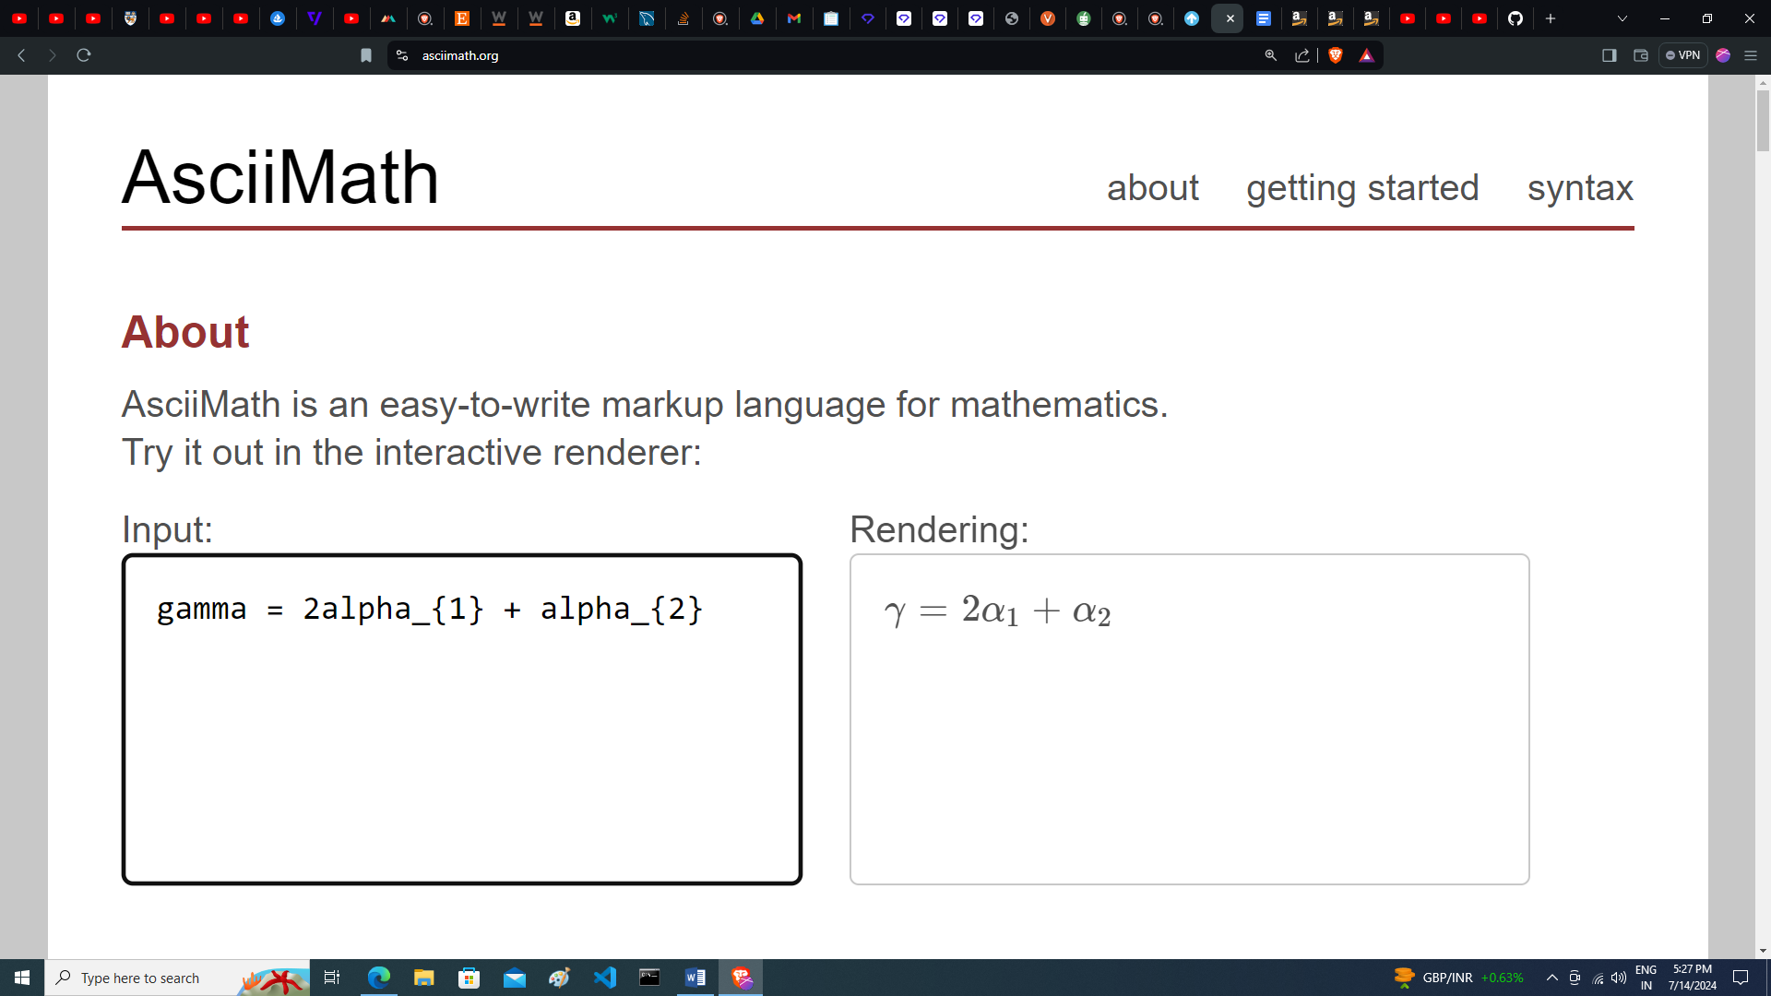

Some times the value of a is different in all three dimensions in a solid say α1 α2and α3 then in that case the value of γ is given as

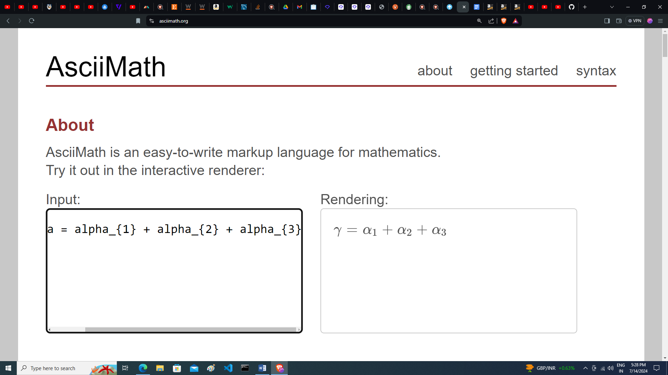

Specific Heat and Absorption of Heat

When heat is supplied to a substance it increases the energy of its molecule and hence its temperature increases. The rise in temperature of substance is proportional to heat supplied to it and also depends on the mass and material of the substance. If ∆Q is the amount of heat supplied to a body of mass m and due to this if its temperature increases by ∆T then this heat supplied Delta\*rho and the rise in temperature ∆T are related as

∆Q = ms∆T

If, m = 1gm and ∆T = 1⁰ C then s = ∆Q thus specific heat of a material is defined as "the amount of heat for unit mass of body to raise its temperature by I°C.”

1 calorie = 4.187 joules

Water Equivalent of a Substance

Water equivalent of a substance is defined as the quantity of water which requires the same amount of heat which the substance requires for same rise in temperature. For example if a body of mass m and specific heat s is heated from temperature T1 to T2 then the amount of heat required for the purpose is

Q = ms(T2- T1 )

If mw is the mass of water which requires the same heat given ,to range its temperature from T₁ to T₂ then we have

Q = ms(T₂-T₁) = mwsw(T₂-T₁)

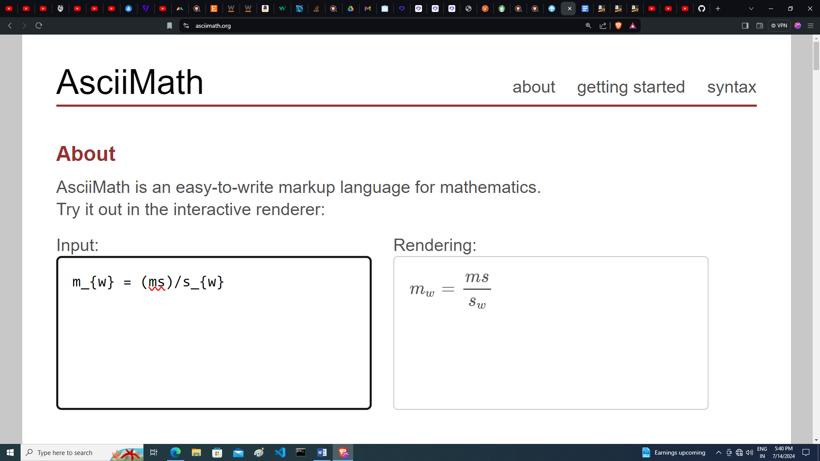

This gives the water equivalent of the body.

Phase transformation

Latent Heat which is characteristic property of a solid substance. It is defined as the amount of heat required to melt a unit mass of solid, denoted by Land termed as latent heat of fusion. If Q is the heat, which melt a mass m of a solid substance with latent heat of fusion L then we have

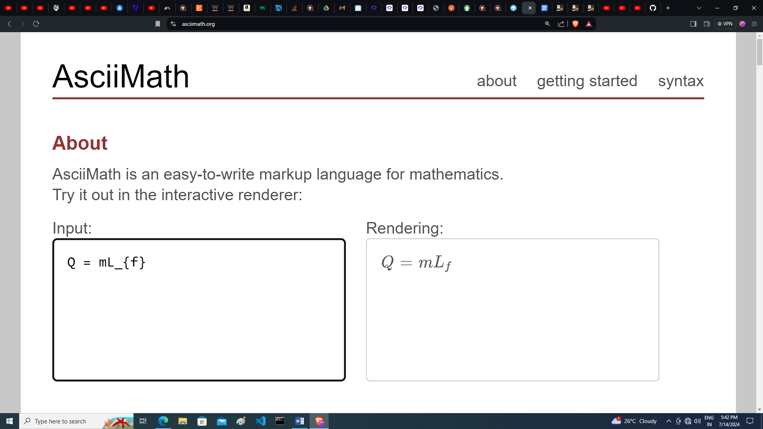

The amount of heat required to vaporize unit mass of a liquid is called as latent heat of vaporization of the liquid and is denoted by L₁. The amount of heat required to vaporize a liquid of mass m is

